**Project Report – E-Smart Application**

CS-5551 ASE

We have been able to implement the following features for the first increment.

1. Login & Registration
2. Home Page
3. Energy Analyzer
4. Home Comfort System

**Mobile UI Design**

To design the mobile UI, we have used a combination JQuery Mobile. We have HTML5 and css for styling the front-end. Most of the features have been supported by google webservices.

**Class Diagram**

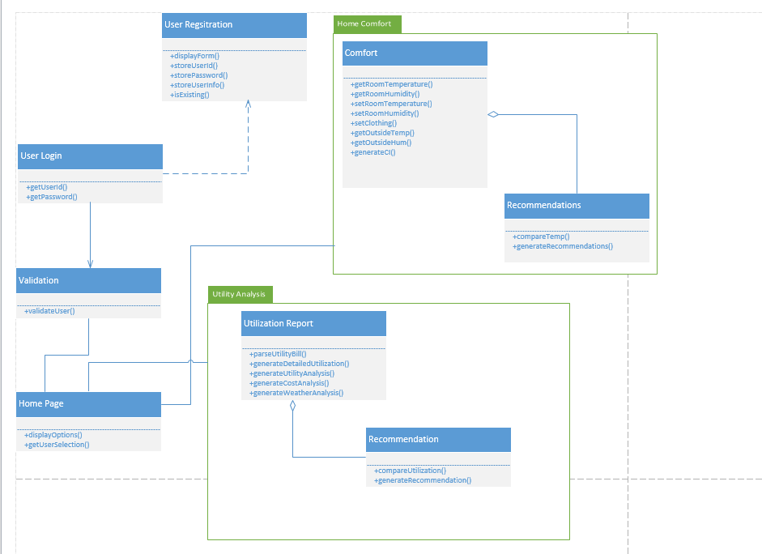

**Sequence Diagrams**

1. User Login and Service request

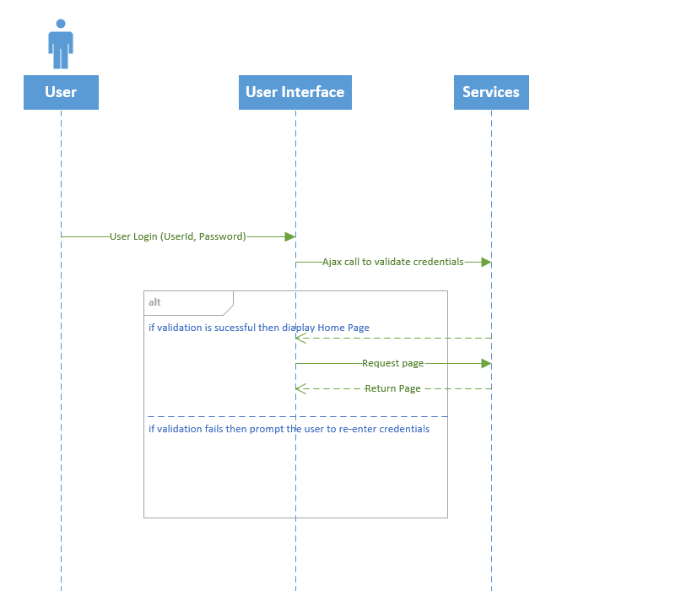

1. User Registration

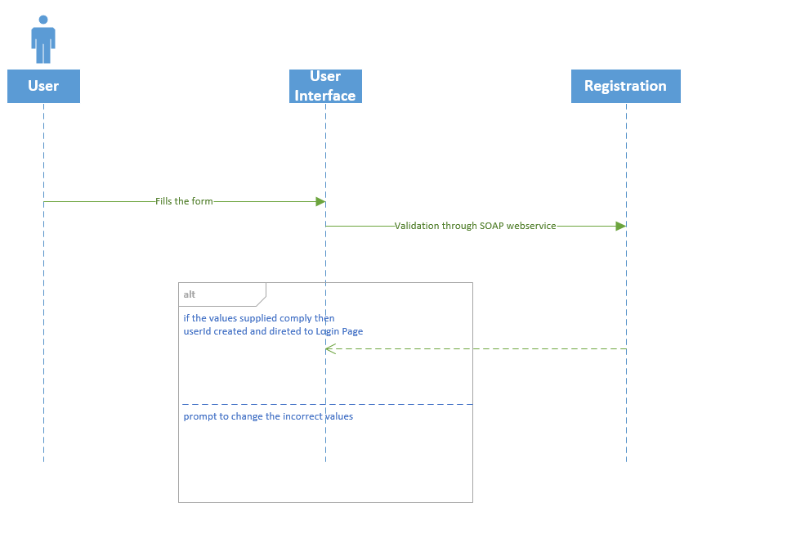

**Implementation Details**

The details of the features are below:

**4) Home Comfort**

**Webservices/API:**

* The geocode function supported by the browser has been used to detect user’s current location.
* The weather webservice by wunder “api.wunderground.com” has been used to populate the temperature and humidity.
* The jQuery UI sliders have been used for sliders on the home comfort page.
* The “google.visualization.Gauge” has been used to get the gauge.

**Implementation Details:**

On successful login the user is directed to the E-Smart homepage.

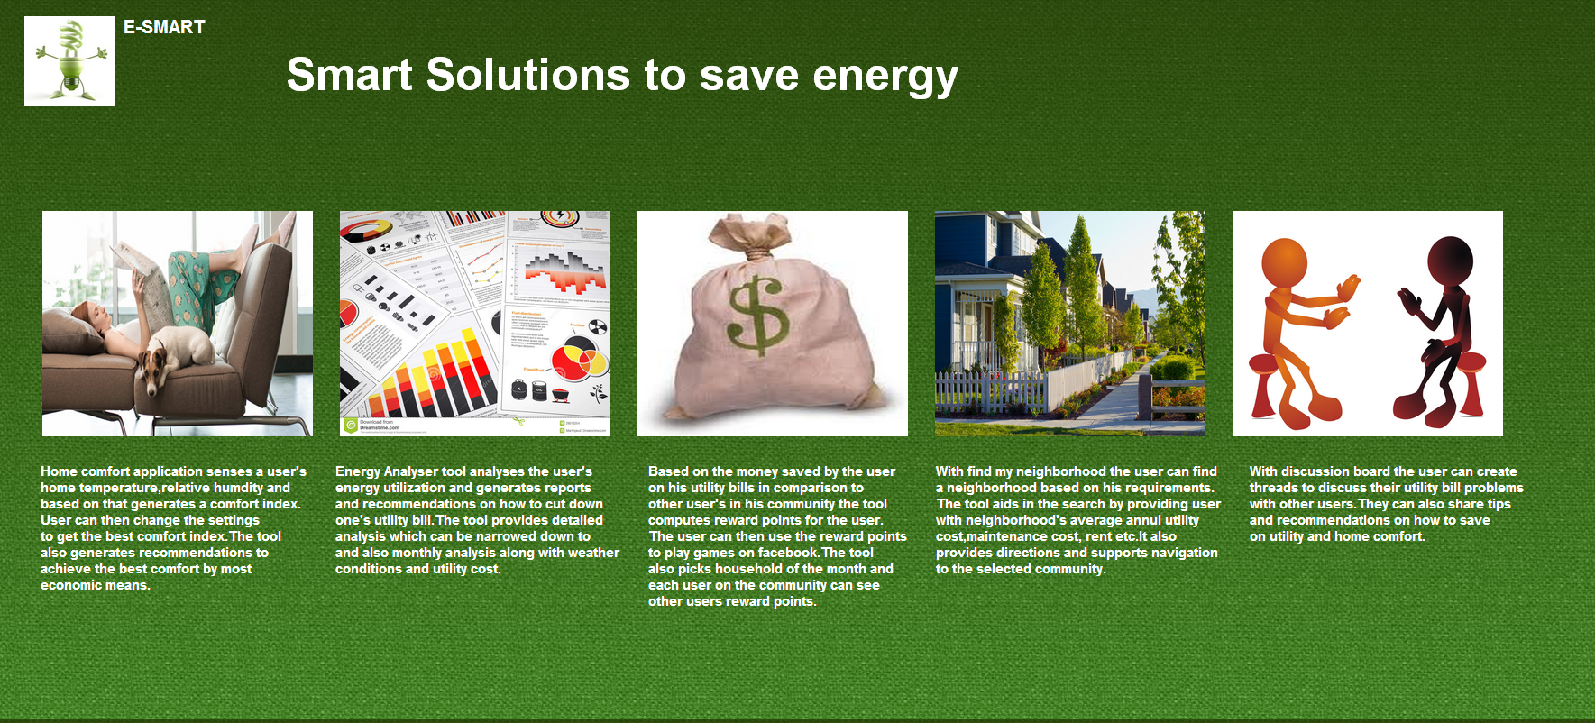

User Clicks on the Home Comfort Image.

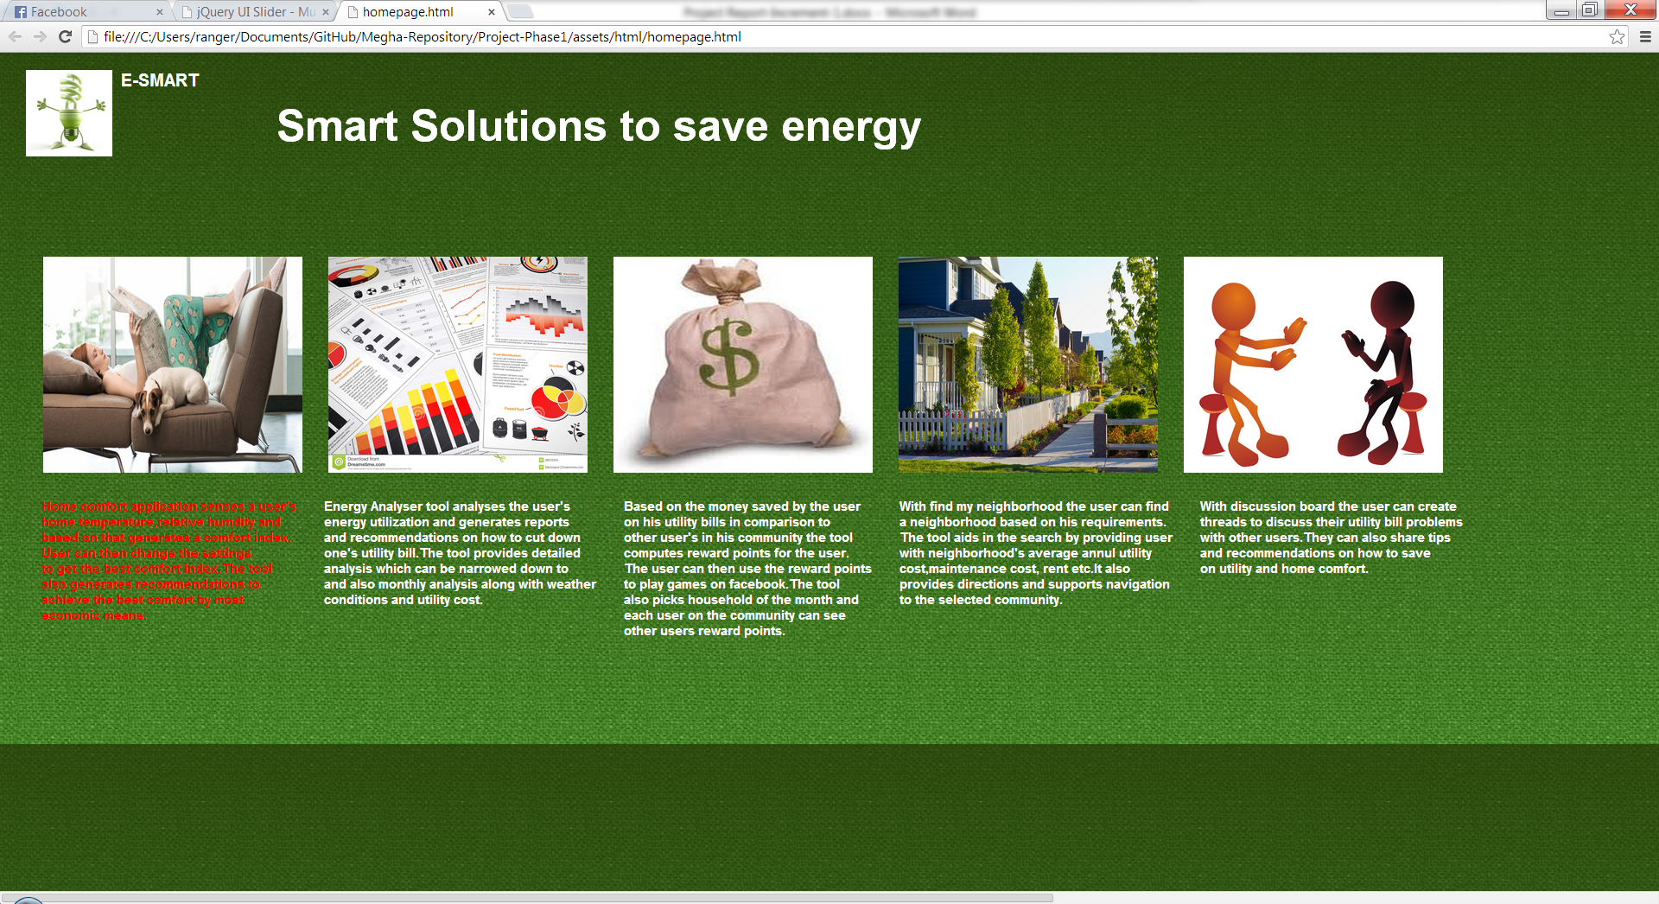

The Page displays the user’s current home temperature and humidity and computes the Comfort Index of his home environment. This page also shows the outside temperature and humidity and a message providing an explanation of the comfort index.

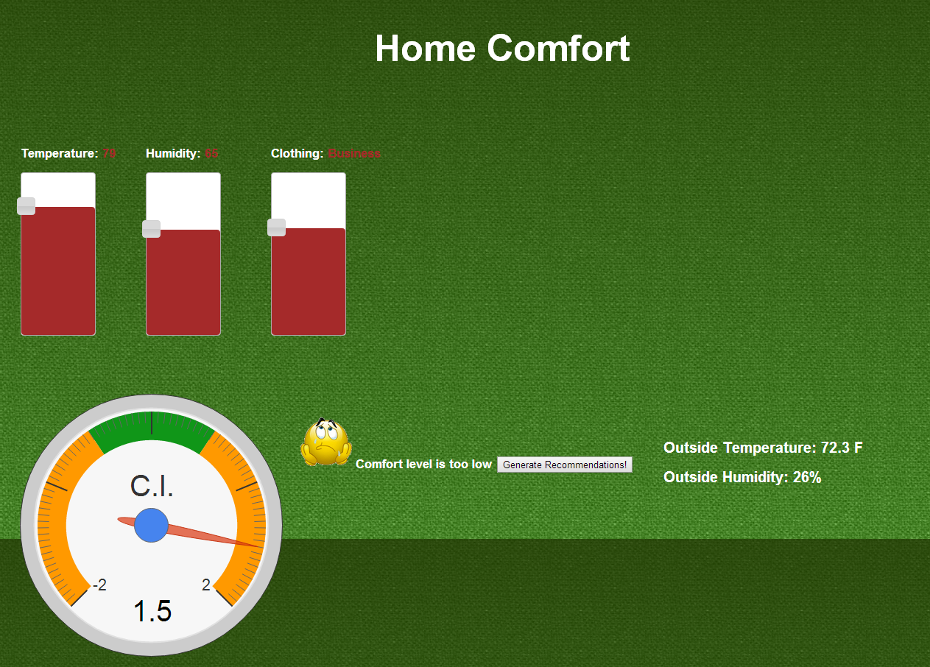

When the user clicks on the Generate Recommendations a list of recommendations are displayed. These recommendations are created by performing computation on his current home environment.

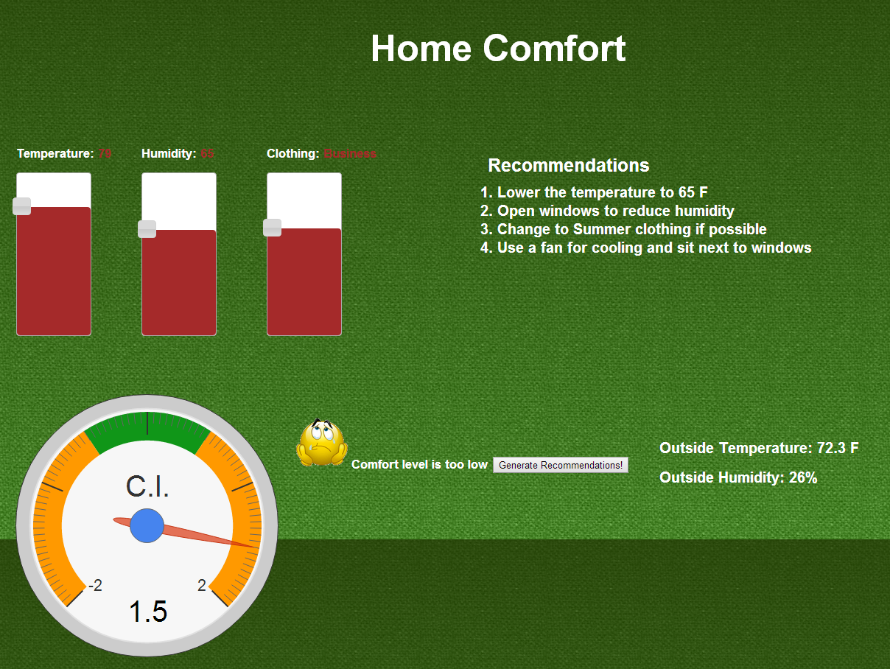

The user then tries to change the temperature, humidity and clothing based on the recommendations and the new comfort index is computed and displayed.

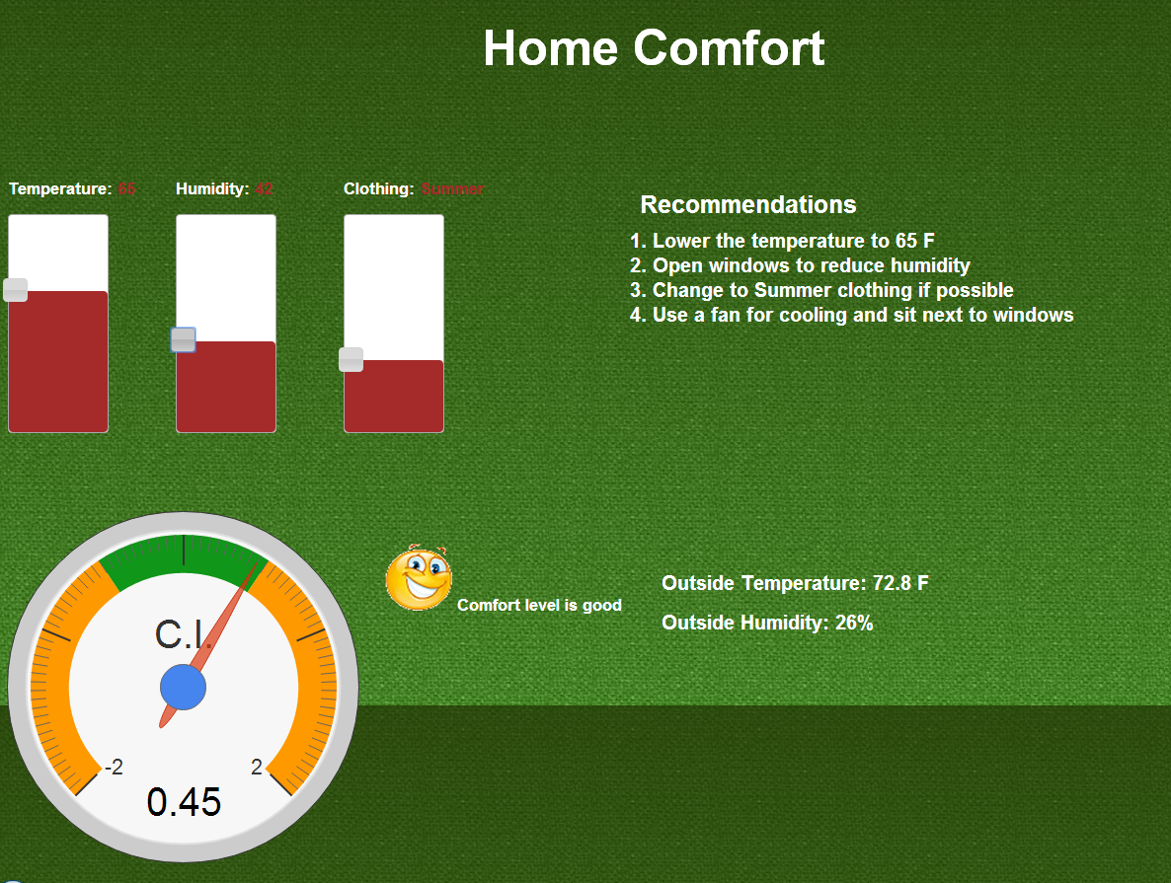

If the user sets the temperature too high or too low then the system prompts an alert message.

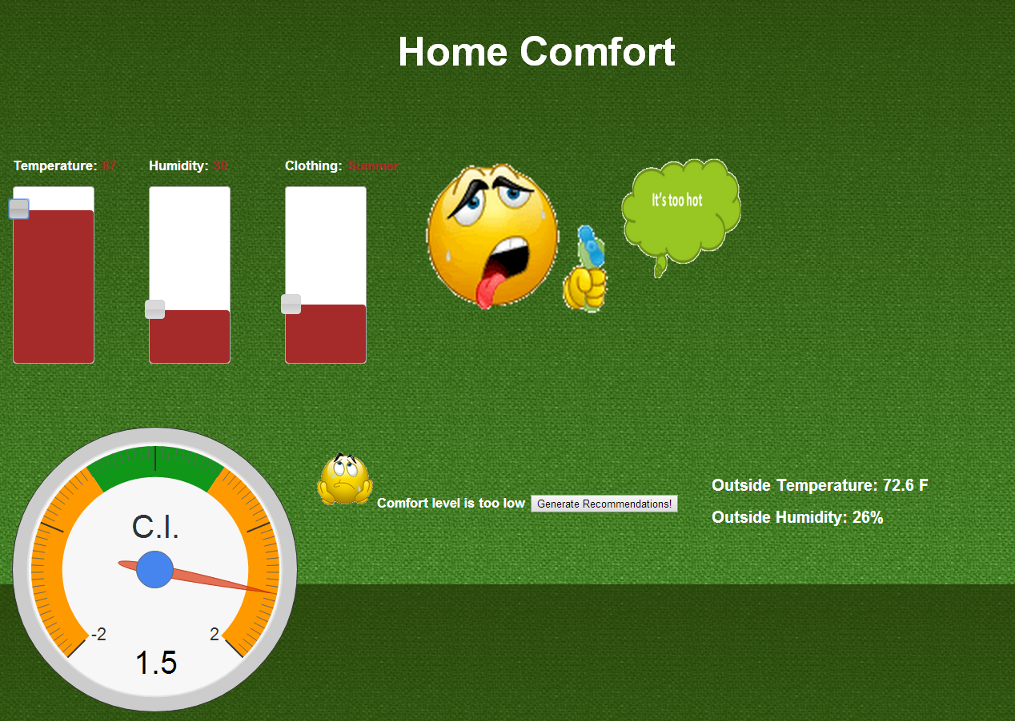

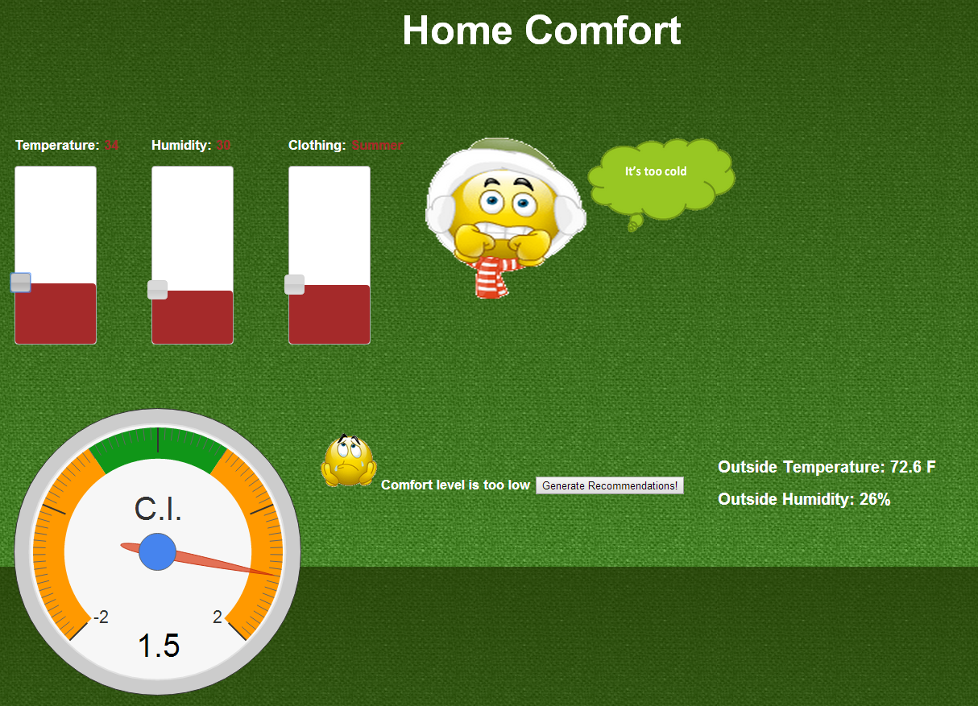

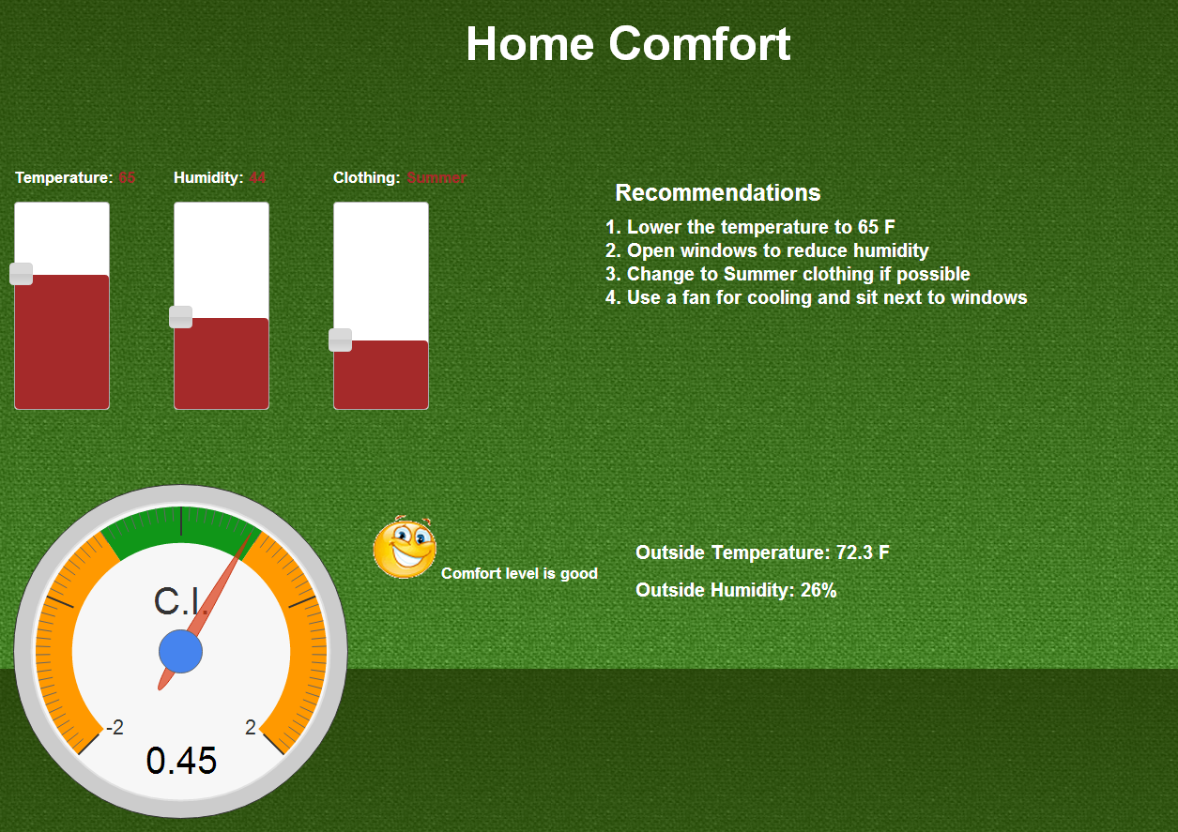

The comfort index is now in the green zone so the user’s home environment is now comfortable.